Sustaining the Digital Record: Preservation Risks in
Born-Digital Archival Materials

Keith Allen
keith.allen@usm.edu
April 22, 2026
Stacy Creel, PhD.
Brendan Fay, PhD.

INTRODUCTION
The growth of born-digital materials has greatly changed the way libraries, archives, and research institutions operate when it comes to storage, accessibility, and dissemination. Research datasets, records, scholarly works, and cultural ephemera are now created and preserved exclusively in digital form rather than through physical objects. Although digital technologies provide exceptional abilities for dissemination and provide unparalleled access, they also introduce challenges related to long-term preservation. Unlike analog materials, digital objects depend on evolving technology for continued access and usability. As a result, digital files may become inaccessible when the software, hardware, or file formats required to interpret them are no longer supported (Hedstrom, 1997; Conway, 2010).
Obsolescence of file formats is one of the most significant threats to digital collections. File formats determine how digital information is accessed and interpreted. When formats become outdated or unsupported (by the software vendor, operating systems, or developers), the content may no longer be accessible without the use of specialized tools or migration strategies. Research performed as early as 2000 emphasized the vulnerability of digital formats and the risks associated with technological changes (Lawrence et al., 2000). Later studies have reinforced the need for monitoring and preservation planning to ensure that digital materials are accessible in the future (Lavoie, 2014; Rosenthal, 2018). As digital collections expand in size and usage, appreciating the preservation risk of file formats has become an essential part of digital stewardship.
Institutional repositories play an important role in storing and providing access to digital files, and that role is becoming more pronounced. They store a wide range of materials, including datasets, images, and multimedia created across numerous disciplines over different technological eras. They have become essential components of research infrastructure, supporting both open access and long-term preservation (Narlock et al., 2024; Phillips, 2015). However, the diversity of file types located in repositories creates preservation challenges because repositories must accommodate formats from many disciplines and technologies.
Digital preservation frameworks such as the Open Archival Information System (OAIS) serve as guideposts for managing digital assets and maintaining long-term access to digital information (Consultative Committee for Space Data Systems, 2012). The subject of much literature on digital preservation focuses on factors like policy development, preservation maturity models, or institutional readiness for preservation programs (Ahmad et al., 2022; Kaczmarek, 2017; Ndegwa, 2022). These studies are important to the field of digital information, providing valuable insight into ruling structures, organizational capacity, and preservation planning. However, they often emphasize institutional preparedness rather than examining the technical characteristics of the actual digital materials stored within the repositories and thus don’t provide a blueprint for ensuring long-term access.
Despite an increased number of published studies and literature about digital stewardship, fewer studies examine the actual files stored within repositories to determine which format types they contain and what preservation risks those formats may present. Identifying the file formats within these collections is important in determining long-term accessibility challenges. Analysis of the content of repositories can reveal patterns of format use that may not be apparent through policy research alone. This analysis provides insight into how format-related risks develop within repositories. Examining the technical makeup of the files and specifically the formats included within a repository therefore represents an important step in developing evidence-based digital preservation strategies.
Research Gap
Although digital preservation research has produced extensive repository policy guidance, fewer studies examine their actual content to identify the file formats present within digital collections. As a result, much of the literature addresses preservation planning at a conceptual or institutional level rather than analyzing the technical characteristics of the stored files. Without direct analysis of repository collections, it is difficult to understand how format-related preservation risks become issues in a practical sense. Addressing this gap requires thorough and systematic analysis of repository files using automated format identification tools that can evaluate large numbers of files. Such analysis can provide empirical evidence that supports more effective digital preservation planning.
Recent studies illustrate the importance of data-driven approaches for understanding digital preservation challenges. Studies examining format prevalence, metadata quality, and repository systems demonstrate that large-scale analysis can reveal patterns and vulnerabilities that may not be visible through policy evaluation alone (Park & Tosaka, 2010; Rosenthal, 2018). Automated tools such as DROID and technical registries such as PRONOM allow researchers and preservation professionals to identify file formats and evaluate potential preservation risks (Knight, 2015; The National Archives, n.d.). These tools allow analyses of digital collections that are both systematic and reproducible.
This study is built on these developments and examines file formats within datasets from the Harvard Dataverse repository. Harvard Dataverse is one of the largest open-access research data repositories and hosts datasets contributed by researchers across many disciplines from around the world. The platform’s openness, extensive documentation, and API accessibility made it well suited for large-scale analysis of repository content (Harvard Dataverse Project Documentation, n.d.). By identifying the formats present in its datasets and evaluating their preservation risks, this study contributes evidence to discussions about digital sustainability and long-term access to digital data. This method of research also demonstrates how repository-level analysis can inform practical preservation strategies.
Through automated format identification and quantitative analysis, this research identifies the formats present within a sample of repository files and determines their preservation risk. By examining actual content rather than relying solely on theoretical frameworks or policy analysis, the study provides insight into how format-related preservation challenges appear in real-world repository environments. This empirical approach helps determine how technical characteristics of files may affect long-term accessibility. The findings are intended to inform digital preservation planning and create a practical workflow that libraries and archives can use to evaluate preservation risks within their digital collections.
Purpose Statement
The purpose of this study is to examine the file formats in selected datasets from the Harvard Dataverse repository and to evaluate their potential preservation risks using automated format identification tools and format registry classifications. By analyzing repository files and identifying formats that may be vulnerable to obsolescence, this study aims to identify preservation risks within these institutional repositories. The research also seeks to demonstrate a workflow that may be replicated for assessing sustainability within digital repository environments. This approach contributes practical instruction for libraries and archives responsible for maintaining long-term access to digital collections. This analysis provides insight into the technical characteristics of digital files. Understanding these characteristics helps institutions develop more effective preservation strategies.
Research Questions
R1: What image file formats are present in a random sample of image files from the Harvard Dataverse repository?
R2: What is the frequency distribution of these formats within the sampled dataset?
R3: Which formats exhibit characteristics associated with preservation risk according to documentation and software support recorded in the PRONOM registry?
R4: What proportion of the sampled files are stored in formats classified as sustainable for long-term digital preservation?
Definitions

Born-digital materials: Information objects that were created in digital form, as opposed to digitized from an analog source (Thibodeau, 2002).
Digital preservation: The series of managed activities necessary to ensure continued access to digital materials for as long as necessary (Lavoie, 2014).
DROID (Digital Record Object Identification): A software tool developed by The National Archives (UK) that identifies file formats by comparing internal binary signatures against format signatures stored in the PRONOM registry (Knight, 2015).
File format obsolescence: The process by which a digital file format becomes unsupported by contemporary software or hardware, reducing its accessibility (Rosenthal, 2010).
Format sustainability: The likelihood that a digital file format will remain accessible over time based on factors such as open documentation, widespread adoption, and continued software support (Lawrence et al., 2000).
Institutional repository: A digital collection managed by an institution that captures, preserves, and provides access to the intellectual output of a research community, including publications, datasets, and other scholarly materials (Lynch, 2003).
Persistent Unique Identifier (PUID): A unique identifier assigned by the PRONOM registry to a specific file format signature, enabling digital preservation tools to identify and reference file formats consistently across systems (The National Archives, n.d.).
PRONOM: A technical registry maintained by The National Archives (UK) that provides detailed information about file formats, including format signatures, version histories, and risks of technological obsolescence (The National Archives, n.d.).
Research infrastructure: the physical, digital, and organizational resources—such as laboratories, data sets, and equipment—that enable the scientific community to conduct, support, and advance high-level research (REMEDi4ALL, n.d.)

Delimitations
This study is limited to files publicly accessible through the Harvard Dataverse repository. The analysis focuses exclusively on image files retrieved from the repository and does not examine other file types such as audiovisual materials, software files, or research datasets. The dataset analyzed in this study consists of a random sample of 1,641 downloadable files obtained through the Dataverse application programming interface (API). Proprietary datasets, restricted-access collections, and files not retrievable through the repository API are not included in the analysis. The study is further limited to file format identification and preservation risk evaluation using the DROID format identification tool and documentation available in the PRONOM technical registry. Other digital preservation tools, registries, or risk classification frameworks are outside the scope of this research.
Assumptions
Several assumptions related to the research design and data collection procedures frame this study. It is assumed that the DROID format identification tool accurately identifies file formats by comparing file signatures with those documented in the PRONOM registry. The study also assumes that the technical documentation available in the PRONOM registry accurately reflects the characteristics and software support associated with the identified formats. Additionally, it is assumed that files retrieved through the Harvard Dataverse application programming interface represent valid and accessible repository content. The random sampling procedure used in the study is assumed to produce a dataset that reasonably reflects the range of image formats present within the repository. It is also assumed that the sampled files have not been altered during the automated download and storage process used for analysis.
Significance of the Study
This study contributes to understanding the preservation challenges inherent to born-digital materials in institutional repositories. As digital scholarship grows more prevalent, repositories are increasingly more responsible for ensuring long-term access to a wide range of digital materials that is only becoming more diverse as technology evolves. This responsibility requires not only developing preservation policies and maintaining infrastructure but also possessing an understanding of file formats and the risks those formats may pose over time. Examining these files provides insight into preservation challenges that may affect long-term accessibility. These insights can help repository managers make more informed decisions about format management and preservation planning.
A substantial body of digital preservation literature exists, focused on frameworks, policies, and organizational preparedness. However, little research examines the technical characteristics of files stored within those organizations’ institutional repositories. By conducting empirical analysis of those files, this study finds patterns of format diversity, identifies vulnerabilities, and provides evidence that can inform preservation guidelines. This contribution helps bridge the gap between preservation theory and the practical realities of managing digital collections.
The study is also significant because it demonstrates a workflow that may be practically replicated for evaluating preservation risk within digital repositories. By combining automated file sampling, format identification tools such as DROID, and classification systems such as the PRONOM registry, the research demonstrates how repositories can conduct format audits of their collections. This approach allows librarians, archivists, or technicians to identify formats that may require additional preservation attention and to prioritize actions such as format migration, normalization, or enhanced documentation. Demonstrating this workflow also provides a practical model that other repositories can adopt when appraising the sustainability of their digital collections. This workflow’s ability to be replicated strengthens the study’s value by promoting consistent preservation practices across repository environments.
Institutional repositories play a key role in the research infrastructure, serving as platforms for data sharing, open access, and dissemination (Narlock et al., 2024; Rieh et al., 2007). However, the long-term usability of their content depends on the unabated accessibility of the file formats in which that content is stored. By analyzing the presence and preservation status of formats within datasets, this study contributes to the body of literature in library and information science while also providing practical insight for librarians, digital archivists, and repository managers responsible for maintaining long-term access to born-digital materials.
LITERATURE REVIEW
The long-term preservation of digital materials has become a primary concern for libraries, archives, universities, and other research institutions. As digital formats become more prevalent in research and archives, institutions have to ensure that digital materials remain accessible despite ongoing changes. Unlike physical objects, digital media depend on technological aspects that include file formats, software applications, and storage systems. Changes in any of these can threaten the accessibility of the digital content. Because of the vulnerability of digital holdings, preservation has become a major focus of research in the library and information science field. This literature review examines scholarship related to digital preservation theory, repository stewardship, file format sustainability, and technical tools used to identify preservation risks. Together, these bodies of research provide the conceptual and methodological foundation for analyzing file formats within repository environments.

Digital Preservation Theory and Sustainability
Early digital preservation research emphasized the vulnerability of digital information and the risks associated with technological obsolescence. Hedstrom (1997) characterized digital preservation as a “time bomb,” warning that digital materials require continuous technological support and intervention to remain accessible (p. 189). Unlike traditional archival objects that may remain usable for decades with minimal maintenance, digital objects both depend on and are threatened by evolving technology. Changing hardware platforms, operating systems, and software applications must remain compatible with the formats used to encode digital information. Conway (2010) expanded on these concerns by distinguishing the mere digitization of physical objects from actual preservation, emphasizing that creating digital versions alone does not guarantee long-term accessibility. These early concerns about technology and long-term access led to the development of preservation guidelines to help direct the sustainable management of digital collections.

Guidelines for digital preservation have been developed to help address these challenges. One of the most widely used frameworks is the Open Archival Information System (OAIS) reference model, which provides a structured approach to managing digital collections over the long-term (Consultative Committee for Space Data Systems, 2012). OAIS describes the main responsibilities of a digital archive, including ingest, storage, data management, access, preservation planning, and administration. Lavoie (2014) explains that the OAIS model helps repositories function as trusted systems by explicitly outlining the processes needed to maintain the authenticity and usability of a repository’s digital materials. Preservation planning, especially, is important because it helps institutions monitor technological changes and identify risks related to file formats and software dependencies.

Despite the creation of these guidelines and recognition of responsible preservation tasks, research has shown that not all institutions are capable of fulfilling those duties. Researchers have looked at how capable institutions are in implementing digital preservation strategies into their workflow. Dollar and Ashley (2014) developed the Digital Preservation Capability Maturity Model (DPCMM) as a way to evaluate an institution’s readiness for digital stewardship. The model outlines explicit criteria and performance metrics that can be used to assess preservation efforts. It also describes different levels of readiness, ranging from inconsistent practices to fully integrated preservation programs. This framework offers a useful way to understand how institutions evolve, building and improving their digital preservation systems over time.

Even with frameworks like this in place, many institutions are still in the early stages of developing effective preservation strategies. Ahmad, Rahman, and Karim (2022) found that university libraries often lack the funding, technical infrastructure, and trained staff needed to support long-term preservation efforts. Their study shows that recognizing the importance of preservation is not always enough to ensure it is fully implemented. Similarly, Anyaoku (2019) observed that preservation policies are often inconsistent or not clearly defined. Together, these findings suggest that successful digital preservation depends not only on awareness, but also on sustained support, resources, and clear organizational planning.

Institutional Repositories and Digital Stewardship

Institutional repositories have become increasingly important infrastructures for managing digital materials. Early research by Rieh, Markey, St. Jean, Yakel, and Kim (2007) found that many repositories were initially designed to primarily support access and dissemination rather than long-term preservation. Their study also showed that preservation planning was often secondary to usability and visibility in early repository development. Phillips (2015) later argued that repositories should be understood as components of broader digital preservation ecosystems that require sustainable format management and metadata practices. Phillips further emphasized that repositories must actively support long-term access rather than simply store digital materials.

Phillips (2015) examined how repositories function within larger digital preservation systems and emphasized their role in long-term stewardship. The study highlighted the importance of using sustainable file formats, maintaining high-quality metadata, and ensuring storage redundancy. These practices support continued access to digital materials as technologies evolve. More recent work by Narlock, Calvert, Taylor, Preisman Marquez, and Parkman (2024) highlights the expanding role of repositories in supporting research data sharing and knowledge infrastructures. Their study found that repositories now play a key role in enabling open science while managing increasingly diverse digital materials created across different technical environments. This diversity introduces preservation challenges because some formats require specialized software or technical support to remain accessible. The authors also emphasize that growing format complexity requires repositories to adopt more proactive preservation strategies. Taken together, these findings show that repositories are evolving from simple access platforms into more complex digital stewardship systems.

Ndegwa (2022) examined repositories’ digital preservation policies and discovered that many operate without formal, structured preservation plans or systematic risk management strategies. This lack of structured planning hinders institutions’ ability to respond effectively to changes in technology. Rieger (2021) further demonstrated that successful digital preservation depends on coordination among technical systems, institutional policies, and organizational leadership. Repositories with integrated governance structures and clearly defined preservation strategies were more successful at maintaining long-term access to digital materials. These findings highlight the issue of preservation challenges not being only resource-based but also structural, requiring coordinated planning and long-term institutional commitment.

File Format Obsolescence and Preservation Risk
One of the most widely discussed risks associated with digital preservation is the obsolescence of file formats. They determine how digital information is stored and interpreted, shaping how software renders digital content. When formats become unsupported by commonly used software, the data contained within those files may become inaccessible to the average user. This loss of access can significantly affect the long-term usability of that digital material. Because of this, monitoring a format’s sustainability has become a primary concern with digital preservation research.

Early research of digital preservation efforts sought to determine the factors that played into a file format’s long-term accessibility. Lawrence, Kehoe, Rieger, Walters, and Kenney (2000) conducted one of the earliest studies of digital file formats and like similar studies of the same era, recognized the importance of open documentation and contributors using widely adopted file formats. Their research emphasized that formats that are widely used, openly documented, and supported by multiple platforms are far more sustainable than proprietary or poorly documented formats, making the choice of file format by contributors the single most important factor in a file’s long-term viability. As a result, preservation professionals prioritize widely adopted formats. Subsequently, the majority of a repository’s collection reflect these more common file types.

Later research examined how often file formats actually become obsolete in practice. Rosenthal (2018) analyzed the usability of file formats across digital repositories and found that large-scale format loss occurs less often than earlier researchers predicted. However, the study also showed that format sustainability cannot be assumed simply because a format is currently usable. Formats tied to specialized software or proprietary systems may still present long-term preservation risks. These findings highlight the need for ongoing monitoring of format usage within digital collections.

More recent studies have explored how file formats are used within institutional repositories. Krishnamurthy (2024) found that repositories often contain a mix of well-established formats and newer formats associated with emerging technologies. This mix creates varying levels of preservation risk across repository collections. Repositories that contain higher proportions of proprietary or specialized formats may face greater long-term preservation challenges. Monitoring format usage therefore helps repositories identify potential preservation risks within their collections.

Research on the characteristics of digital objects has further complicated discussions of format sustainability. Matthews, McIlwrath, Giaretta, and Conway (2008) introduced the concept of significant properties, which refers to the essential characteristics that must be preserved to maintain a digital object’s authenticity and usability. Their work emphasizes that preservation decisions cannot focus only on file formats. Instead, preservation strategies must also consider the functional features that define how digital objects are created, displayed, and interpreted. Understanding these characteristics helps repositories choose appropriate strategies such as format migration or emulation.

Automated Tools for Format Identification and Preservation Analysis
As digital collections grow in size and complexity, automated tools have become essential for managing preservation workflows in repositories. One widely used resource supporting these workflows is the PRONOM technical registry maintained by The National Archives in the United Kingdom, which provides documentation about digital file formats, including format signatures, version histories, and software dependencies (The National Archives, n.d.). Knight (2015) examined how the DROID software tool uses these PRONOM signatures to identify file formats by analyzing the internal binary patterns of digital files. This signature-based approach allows repositories to analyze thousands or even millions of files efficiently while improving the accuracy of format identification compared with extension-based methods. As a result, tools such as PRONOM and DROID help repositories monitor the formats used within large digital collections.

Other tools support related preservation tasks such as file validation. Abrams and Luther (2010) examined the JSTOR/Harvard Object Validation Environment (JHOVE), which verifies file integrity and checks whether files conform to format specifications. Their study showed that validation tools help repositories detect structural problems or inconsistencies within digital files. The researchers also found that combining format identification tools with validation systems improves the reliability and transparency of digital preservation workflows. Using multiple automated tools therefore provides repositories with a more thorough understanding of the technical traits of their digital collections.

The role of metadata in managing digital objects has also been a topic of research. Park and Tosaka (2010) conducted a large-scale survey of metadata practices across digital repositories and found significant differences in metadata quality and consistency. Without a clearly defined metadata standard for cataloging digital files, incomplete or inconsistent metadata made digital materials harder to discover, manage, and preserve over time. Their findings suggest that structured and consistent metadata is essential for effective repository management. Strong metadata practices also support automated preservation tools by providing reliable descriptive and technical information about digital files.

The development of these tools reflects a broader shift toward analytical approaches to digital preservation. Automated analysis allows repositories to examine the technical characteristics of their digital collections more directly. These tools make it possible to evaluate large numbers of files efficiently as repositories continue to grow. By identifying file formats, confirming file structures, and supporting metadata management, automated systems help repositories monitor their collections and their sustainability. Together, these technologies support scalable preservation practices and help institutions plan for long-term access to digital materials.

Emerging Challenges in Digital Preservation
With the adoption of preservation systems and automated tools, repository management has improved over time. Emerging risks still exist, however, affecting the long-term sustainability of digital materials. Digital scholarly publications are especially vulnerable, as Eve (2024) found that many digital journals lack preservation safeguards. This poses a real challenge to the long-term accessibility of research data. These findings suggest that even those forms of digital scholarship that are widely distributed may still be vulnerable if preservation strategies are not implemented.
Other challenges and risks associated with digital preservation have also been extensively researched. Trognitz (2024) argues that attempting to preserve digital files outside an established, formal archival infrastructure presents its own significant risks. In these systems, duties and responsibilities are not clearly defined and can be overlooked within the workflow. Without concentrated, coordinated preservation strategies, digital materials may become fragmented and distributed across multiple systems with differing levels of technical support. This can complicate efforts towards long-term accessibility and consistent preservation management.
Digital preservation entails multiple levels of complexity and because of the significance of these efforts in the field, much research has been performed to study them. Jalaludin, Rahman, and Ismail (2025) found that there are recurring themes that pose challenges to preservation efforts. These challenges are most often related to technological changes, financial limitations, and policy development, identifying that many institutions continue to struggle against these in their efforts to establish and implement digital preservation workflows. These findings highlight the gap between theoretical preservation models and the real-world realities faced by many institutions. By analyzing the formats and structures of digital holdings, librarians, archivists, and technicians can identify potential risks that may affect long-term accessibility and inform more effective preservation strategies.

Gap in the Literature
Across the literature, researchers emphasize the importance of monitoring digital preservation risks and developing sustainable stewardship practices. Much of the existing research, however, focuses on theoretical frameworks, organizational policies, or institutional preparedness, often overlooking the technical characteristics of repository collections. As a result, the digital objects themselves are less thoroughly studied than the structures designed to manage them. This gap is reflected in the limited number of empirical studies examining file formats and preservation risks within large institutional repositories, including widely used platforms such as Harvard Dataverse. Examining the formats and structures of repository content can provide valuable insight into potential vulnerabilities and support more effective preservation decision-making.
By analyzing file formats within a sample of repository files using automated identification tools, the present study contributes empirical evidence to this area of research. Examining the prevalence and characteristics of file formats within repository datasets provides insight into potential preservation risks. These findings also clarify how format-related challenges appear within real-world repository environments. In doing so, the study supports more informed digital stewardship practices within institutional repositories.
Summary of the Literature
Digital preservation is an important concern for libraries, archives, and research institutions as digital collections and their role in the academic and research infrastructures continues to grow. Research has shown that digital materials are vulnerable, especially as technologies become outdated over time. Frameworks such as the Open Archival Information System (OAIS) provide guidance for managing and preserving digital collections. Studies of institutional repositories highlight their growing role in preserving research materials and data but also show that many repositories still face challenges with long-term preservation. Together, this research helps explain the technical and organizational factors that shape digital preservation practices.
Two key factors that influence long-term accessibility are format selection and monitoring. Studies of file format sustainability have found that formats that are widely adopted, openly documented, and supported by multiple software platforms are more sustainable than proprietary or poorly documented formats. But because repositories often contain a mixture of both established and emerging formats, there are varying levels of preservation risks. Understanding the distribution of these formats is therefore and important step in developing effective digital preservation strategies.
The increasing importance of automated tools for analyzing digital collections is also a subject of interest in much of the literature. Resources like the PRONOM technical registry and format identification tools like DROID enable preservationists to evaluate their repository’s files at scale by format and identify possible preservation risks within the large collection. Manual inspection of a digital collection would be virtually impossible but automated tools allow archivists, librarians, or preservation technicians to analyze the technical composition of the collection far more efficiently. As digital collections continue to grow in both size and complexity, automated analysis becomes increasingly necessary for an effective preservation program.
Despite these developments, relatively few studies conduct systematic analyses of file formats within large institutional repositories. This study addresses this gap by applying automated format identification and registry-based analysis to a sample of files retrieved from the Harvard Dataverse repository. By examining the formats present within repository datasets, the study contributes empirical evidence about format distribution and preservation risk. This approach helps connect theoretical preservation frameworks with the technical realities of repository content. The following chapter describes the methodology used to collect, identify, and evaluate file formats within the sampled dataset.
Previous research has also applied computational methods to analyze the technical characteristics of digital collections. Studies using tools such as DROID and PRONOM have demonstrated how automated format identification can be used to examine large datasets efficiently. These approaches typically involve extracting file format identifiers, linking them to registry documentation, and evaluating preservation characteristics based on factors such as software support and documentation availability. By using standardized tools and workflows, these studies provide consistent and reproducible methods for assessing digital preservation risks. This methodological foundation supports the use of automated format analysis in the present study.
Several studies reviewed in this chapter have used computational tools and registry documentation to analyze digital collections. Building on these approaches, this study uses automated format identification with the DROID software tool and information from the PRONOM registry to examine file formats within a repository environment. While previous research has focused on preservation frameworks and institutional policies, this study focuses on the actual files stored in a repository. Automated sampling, large-scale format identification, and registry-based risk evaluation ensure that the study provides an empirical assessment of the sustainability of formats found in repository datasets. The use of automated tools and clearly defined procedures also supports a replicable approach that could be applied to other repositories or digital collections.
METHODOLOGY
Research Design
This study employed a quantitative content analysis of digital files using computational file format analysis tools. Quantitative content analysis was appropriate because it enabled the systematic examination of digital objects through measurable attributes, in this case format identifiers and their preservation characteristics. Rather than interpreting the meaning of digital content, the analysis focused on structural properties of files. Specifically, the study examined the encoding formats used for image data stored within a repository environment.
The research design integrated three methodological components: automated format detection, registry-based format documentation, and statistical analysis of format frequency. Automated format detection identified the technical structure of each file using signature-based identification tools. Registry documentation provided authoritative information about the characteristics and sustainability of each identified format. Statistical analysis was then used to examine the distribution of formats and evaluate their potential preservation risks within the dataset.
Sample Size Justification
The study analyzed a simple random sample of 1,641 publicly accessible image files from the Harvard Dataverse repository. Because the repository contains millions of files, the sample size was determined mainly by the level of precision needed for the analysis rather than by the total number of files in the repository. Using a sample allowed the study to estimate the prevalence of common file formats, such as JPEG, TIFF, and PNG, without analyzing the entire repository. Random sampling also helped reduce the risk of systematic bias in the dataset. Standard statistical methods for estimating proportions were used to determine a sample size capable of producing reliable estimates of format distribution within the repository.
$$n=\frac{Z^{2}p(1-p)}{e^{2}}$$
Using the standard normal approximation for proportion estimates at a 95% confidence level (Z = 1.96) (Creswell & Creswell, 2018) and assuming maximum variability (p = 0.5), a dataset of 1,641 files produces a worst-case margin of error of about ±2.5 percentage points. This level of precision is sufficient to estimate the prevalence of common image formats and determine the share of files that fall into preservation-relevant categories. A margin of error at this level provides reasonably stable estimates of format distribution within the repository sample. In practical terms, this precision allows the analysis to identify dominant formats while still capturing variation within the dataset. As a result, the selected sample size provides a practical balance between statistical precision and feasibility.
A larger dataset also increases the likelihood of detecting rare formats that may present preservation challenges. Although such formats appear infrequently, they can still pose risks for long-term access to digital materials. For example, if a format occurs in about 0.1% of files (p = 0.001), a dataset of 1,641 files provides roughly an 80% chance of observing at least one occurrence. Identifying these less common formats is important because they may rely on specialized software or limited technical documentation. A large dataset therefore improves the chances of capturing both common and uncommon formats within the repository.
The selected dataset size also reflects the efficiency of the automated data collection process used in this study. Image files were retrieved using a Python script that searched the Harvard Dataverse application programming interface (API) and downloaded eligible files automatically. Once the workflow was created, the number of files retrieved could be adjusted simply by changing a parameter that specified the dataset size. As a result, collecting 1,641 files required essentially the same programming effort as collecting a much smaller dataset. This automation allowed the study to scale data collection while maintaining consistent sampling procedures.
Taken together, these considerations make 1,641 files both a statistically appropriate and practically efficient dataset for examining format distribution and preservation risk. The sample size provides enough precision to estimate format prevalence within the repository. It also increases the likelihood of detecting less common formats that may pose preservation challenges, which was the primary reason for including this size dataset. This balance between statistical reliability and practical feasibility is particularly important when analyzing large digital collections. For these reasons, the selected sample size supports both the analytical and practical goals of the study.
Data Collection Procedures
The image files analyzed in this study were obtained from publicly accessible datasets in the Harvard Dataverse repository. The platform stores research data contributed by scholars from many academic disciplines. Harvard Dataverse also provides an application programming interface (API) that allows researchers to retrieve dataset metadata and files automatically. This capability makes the repository suitable for large-scale data collection and analysis. The combination of open-access datasets and programmatic access made Harvard Dataverse an appropriate source for conducting systematic format analysis.
A Python script was developed to search the Harvard Dataverse API and identify datasets containing downloadable image files. The script retrieved metadata describing the files available within repository datasets. These records were filtered using file type information so that only image-based files were included in the candidate pool. This step ensured that the dataset contained only files relevant to the study. A simplified excerpt of the sampling script used in this process is provided in Appendix A.
Eligible files were randomly selected until the target sample size of 1,641 files was reached. To ensure that at least 1,641 usable image files remained after screening, a small overage was included during the random selection process. Some files identified as images through repository metadata were expected to be unsuitable for analysis due to incomplete downloads, duplication, unsupported formats, or failure to meet inclusion criteria. As a result, slightly more files than the minimum target were initially selected and downloaded. Random selection was used to reduce the likelihood of systematic sampling bias and to ensure that each file represented an independent observation within the dataset. This approach preserved the randomness of the sample while ensuring that the final dataset met the study’s target of 1,641 valid image files. The resulting sample reflects a wide range of image formats present in the repository and provides a representative basis for examining format distribution.
The selected files were downloaded automatically and stored locally in a directory prepared for format analysis. Each file retained its original filename and extension as provided by the repository. Preserving these attributes ensured that important format metadata remained intact during analysis. Maintaining the original file information also supported accurate format identification by automated preservation tools. This process allowed the files to be analyzed without altering their original technical characteristics.
By retrieving files through the Dataverse API and applying random sampling, the resulting dataset represents a diverse cross-section of image formats within the repository. The dataset includes materials contributed by researchers from multiple disciplines. These materials reflect a variety of file creation practices and technical environments. This diversity provides insight into the range of formats used within repository collections. Examining formats from different research contexts helps reveal how technical practices shape the composition of repository content.
Technical Workflow and Reproducibility
Data collection and format identification were carried out through a reproducible computational workflow. A Python program was used to search the Harvard Dataverse application programming interface (API) and retrieve metadata describing files available in the repository. The program then identified eligible image files and stored the selected files in a local directory prepared for analysis. Automating these steps reduced the risk of manual error and ensured that the procedure could be applied consistently. As a result, the data collection process can be replicated in future studies using the same scripts and repository access methods.
After the files were collected, the dataset directory was analyzed using DROID. The software examined each file and compared its binary signature with format signatures stored in the PRONOM registry. This method allows DROID to identify file formats based on their internal structure rather than relying only on file extensions. The approach improves identification accuracy, especially when file extensions are missing or incorrect. Accurate format identification is essential for evaluating the preservation characteristics of digital objects.
The results produced by DROID were exported as a spreadsheet for further analysis. The dataset included metadata fields describing each file and its identified format. The analysis then extracted unique format identifiers and calculated how frequently each format appeared in the sample. Each identifier was linked to preservation information from the PRONOM registry to evaluate format sustainability. These steps allowed the study to assess both the prevalence of formats and their potential preservation risks.
Because the sampling script, DROID scanning process, and analytical steps follow clearly defined procedures, the workflow can be replicated by other researchers. Applying the same scripts to the Harvard Dataverse API would generate comparable datasets. Similarly, scanning files with the same version of DROID and PRONOM signatures would produce consistent format identification results. Replicating these procedures allows other researchers to verify the findings and test the methodology in other repository environments. This reproducibility strengthens the reliability and transparency of the study.
File Format Identification Using DROID
File format identification was performed using DROID (Digital Record Object Identification), a digital preservation tool developed by The National Archives in the United Kingdom. DROID identifies file formats by comparing the internal binary signatures of files with format signatures maintained in the PRONOM technical registry (The National Archives, 2024). These signatures represent characteristic byte patterns that correspond to specific file formats. Because the identification process examines the internal structure of files, DROID can determine formats even when file extensions are missing or are incorrect. Signature-based identification therefore improves the reliability of format detection in digital preservation workflows.
After the sampled files were downloaded and organized locally, DROID scanned the dataset and examined the binary structure of each file. When a signature match was detected, the software assigned the file a Persistent Unique Identifier (PUID). Each PUID corresponds to a specific format entry documented in the PRONOM registry. These identifiers provide a standardized way to reference file formats within digital preservation systems. Using standardized identifiers allows researchers and practitioners to analyze and compare format data consistently across collections.
The DROID scan generated a report containing metadata fields such as file name, file extension, format name, format version, and PUID. These fields provide detailed information about each identified file type. The report served as the primary dataset for the next stage of analysis. Extracting these metadata fields made it possible to organize the results into a structured dataset suitable for quantitative evaluation. This structure allowed the study to examine the distribution of file formats within the repository sample.
The DROID output was exported as a comma-separated values (CSV) file and compiled in Microsoft Excel for further analysis. A description of the dataset used for analysis is provided in Appendix D. The compiled dataset included key metadata fields such as file name, file extension, format name, format version, and PUID. These fields allowed the study to organize the format identification results in a consistent format for analysis. The dataset was then used to calculate format frequencies and evaluate preservation risk classifications based on PRONOM documentation.
Files that could not be matched to a known signature were recorded as unidentified formats. These cases may indicate uncommon file types or gaps in the PRONOM registry. In some situations, unidentified files may also result from corrupted files or formats that have not yet been documented. Identifying these files can help preservation practitioners recognize undocumented formats or limitations in format registries. In this study, the DROID output served as the foundation for analyzing format distribution and preservation risk.
Format Risk Assessment Using PRONOM
After file formats were identified, potential preservation concerns were evaluated using the PRONOM technical registry. PRONOM provides documentation about digital file formats, including format specifications, software dependencies, and technical identifiers. Because many files may share the same identifier, the analysis focused on unique Persistent Unique Identifiers (PUIDs) rather than individual files. Unique PUID values were extracted from the DROID output and used to locate the corresponding format entries in the PRONOM registry. This approach allowed the study to evaluate preservation characteristics at the format level rather than examining repeated instances of the same format.
For each identified format, several characteristics were recorded to assess potential preservation concerns. These characteristics reflect common indicators of format sustainability discussed in digital preservation research. Information about documentation availability, software support, and technical dependencies can help indicate whether a format is likely to remain accessible over time. Recording these attributes allowed formats to be evaluated using consistent criteria across the dataset. The attributes documented for each format entry included format name and version, availability of technical documentation, known rendering software, dependencies on proprietary technologies, and evidence of continued software support.
These attributes were used to evaluate format obsolescence risk. In this study, obsolescence risk refers to the possibility that a file may become difficult or impossible to access using currently supported hardware or software environments. Formats that depend on specialized or proprietary technologies may present greater preservation challenges over time. Evaluating these characteristics provided a structured method for assessing potential preservation risks. This approach allowed the study to compare formats based on their likely long-term accessibility.
Based on these characteristics, formats were grouped into three qualitative categories representing different levels of preservation risk. These categories provide a simplified framework for interpreting the sustainability of formats identified in the dataset. The classification reflects common preservation concerns such as documentation availability, software support, and technological dependencies. Grouping formats in this way allows preservation risks to be compared consistently across the dataset. The three risk categories used in this study are defined as low risk, moderate risk, and high risk.
Low risk formats have openly documented specifications and broad software support. Moderate risk formats have more limited support, partial proprietary dependencies, or declining adoption. High risk formats lack reliable documentation, depend on obsolete software environments, or cannot be consistently identified. These categories provide a practical way to summarize preservation concerns associated with different formats. Using these categories made it possible to evaluate format sustainability across the sampled dataset.
Data Analysis and Risk Classification
The DROID output spreadsheet was analyzed to determine how often each file format appeared in the dataset. Duplicate entries were removed using PUID values to create a list of unique formats. Frequency counts were then calculated to show how many files corresponded to each format. These counts provided a quantitative overview of format distribution within the sampled repository files. The frequency data formed the basis for the next stage of preservation risk analysis.
Preservation information from the PRONOM registry was then used to assign risk classifications to each identified format. The criteria used to determine preservation risk levels are described in Appendix F. The dataset included the format name, the number of files using that format in the sample, and the assigned preservation risk category. This classification allowed the study to compare how common each format was with its potential preservation concerns. The analysis therefore identified formats that may require closer monitoring in preservation workflows.
The combined dataset allowed the study to examine both format distribution and possible obsolescence risks within the repository sample. By linking frequency counts with risk classifications, the analysis showed how often different levels of preservation risk appeared in the dataset. The results also highlighted formats that may require additional attention from repository managers. These findings provide insight into the sustainability of formats used within repository collections. The analysis therefore supports more informed preservation planning for managing digital materials in repository environments.
Validity and Reliability
Several methodological considerations support the validity and reliability of this study. These considerations explain how accurately the study measures preservation risk and how consistently the analysis can be repeated. Addressing these issues helps ensure that the findings reflect the characteristics of the dataset that was analyzed. Attention to methodological rigor also helps reduce potential sources of error in the analysis. Together, these factors strengthen confidence in the study’s methods and results.
Internal validity is supported through the use of computational format analysis tools and standardized technical registries. File formats were identified using DROID, which relies on format signatures maintained in the PRONOM registry. Because identification is based on binary signature analysis rather than manual inspection, the process reduces the risk of subjective classification errors. This automated method ensures that format identification is applied consistently across all files in the dataset. As a result, the procedure provides a reliable basis for evaluating the preservation characteristics of the identified formats.
Construct validity is addressed through the study’s definition of preservation risk. In this study, format obsolescence risk refers to the potential inability to access or render data using currently supported hardware or software environments. Risk classifications were based on information documented in the PRONOM registry, including format specifications, software support, and technological dependencies. Using these documented characteristics ensures that risk categories are applied consistently across formats. This approach helps align the study’s concept of preservation risk with the measurable attributes used in the analysis.
Reliability is also supported through automated and reproducible procedures. The dataset was created using a Python workflow that queried the Harvard Dataverse API and randomly selected eligible image files. Because the sampling process is controlled by defined parameters, the procedure can be repeated using the same script and selection criteria. Similarly, the DROID scanning process produces standardized reports when the same software version and PRONOM signatures are used. These automated steps allow the analysis to be repeated consistently across multiple runs.
Finally, transparency in the analytical workflow further supports methodological reliability. The procedures used to extract PUID identifiers, calculate format frequencies, and assign risk classifications are clearly documented. This documentation allows other researchers to repeat the study using similar repository environments and tools. Clear reporting of analytical steps supports transparency and reproducibility in digital preservation research. Such transparency strengthens confidence in the study’s findings and methodology.
Limitations
Because the dataset was drawn from a single repository, the findings reflect the file format characteristics of the Harvard Dataverse environment and may not generalize to other institutional repositories with different disciplinary focuses or repository policies. This limits the broader applicability of the observed format distributions and preservation risk patterns. In addition, format identification depended on the accuracy and coverage of signatures in the PRONOM technical registry, which may not include every existing file format. As a result, some files may remain unidentified or misclassified. These limitations may affect the completeness of format identification and influence the interpretation of preservation risk classifications.
RESULTS
This chapter details the results of the automated format identification and preservation risk analysis conducted on the sampled image files from the Harvard Dataverse repository. The findings address the study’s research questions by identifying the file formats in the dataset, examining how often they appear, and evaluating their preservation risks using information from the PRONOM technical registry. The analysis provides insight into the technical composition of the sampled repository content. These results form the empirical basis for the discussion of preservation implications in the following chapter. Together, the findings offer a clear overview of the technical characteristics of the files included in the sample.
Research Question 1. What image file formats are present in a random sample of image files from the Harvard Dataverse repository?
DROID analyzed 1,641 image files retrieved from publicly accessible datasets in the Harvard Dataverse repository. The analysis identified 22 unique file format identifiers (PUIDs). These identifiers represent several major format families, including JPEG, PNG, TIFF, GIF, JPEG 2000, and newer formats such as WebP and AVIF. The presence of these formats illustrates the wide range of image-encoding practices used in repository datasets. A complete list of identified formats and their preservation risk classifications is provided in Appendix E.
The dataset included multiple versions or variants of some formats. Most files belonged to a small number of widely used image format families. JPEG, PNG, and TIFF formats were especially common in the sample, all of which are widely used in digital imaging and supported across many operating systems, software platforms, and web environments. Their widespread adoption helps ensure continued accessibility. The prevalence of these formats in the sample reflects common practices in digital image creation and data sharing across research communities.
Figure 1 illustrates the distribution of the image format families identified in the dataset. Format families were determined using the PRONOM registry identifiers assigned during the DROID format identification process. The figure shows that most files belong to a small number of widely used format families which are commonly used for storing and sharing images in digital repositories. The distribution highlights the dominance of a few established image formats within the sampled collection.
Figure 1
Image Format Distribution in Harvard Dataverse Sample (n = 1,641)

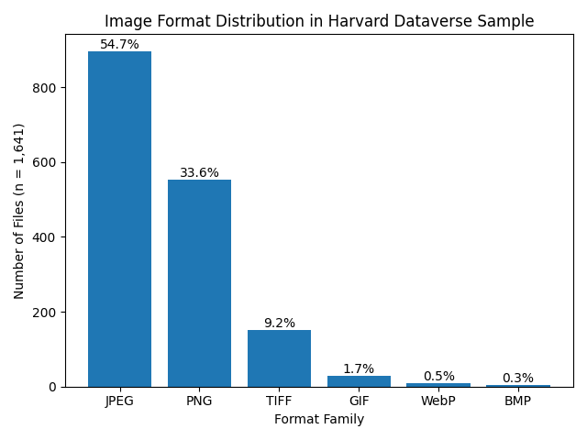
Note. The chart displays the frequency and percentage of image file formats identified in the sampled dataset. JPEG and PNG formats account for the majority of files, comprising over 88% of the sample, while TIFF, GIF, WebP, and BMP appear less frequently. Percentages are based on the total number of files analyzed.
Research Question 2. What is the frequency distribution of these formats within the sampled dataset?
After identifying the file formats, the dataset was analyzed to determine how often each format appeared. The results show that a small number of formats account for the majority of files in the sampled dataset. JPEG, PNG, and TIFF were the most common formats, while JPEG 2000, HEIF/HEIC, AVIF, and WebP appeared much less frequently. This pattern illustrates the dominance of a few widely supported image formats in repository collections. The frequency results therefore show that most image files in the sample belong to a small group of common format families.
Several PUID variants were associated with formats such as JPEG and TIFF. These variants reflect differences in format signatures or versions rather than completely different encoding standards. Files that appear visually identical may still have slightly different internal structures. Automated tools such as DROID can detect these differences by examining binary signatures instead of relying only on file extensions. Identifying these variations helps researchers document the technical diversity of formats within digital collections more accurately.
Table 1 presents the distribution of image file formats identified within the sampled dataset, including the number of files associated with each format.
Table 1
Distribution of the Most Commonly Identified Image Format Families (n = 1,641)
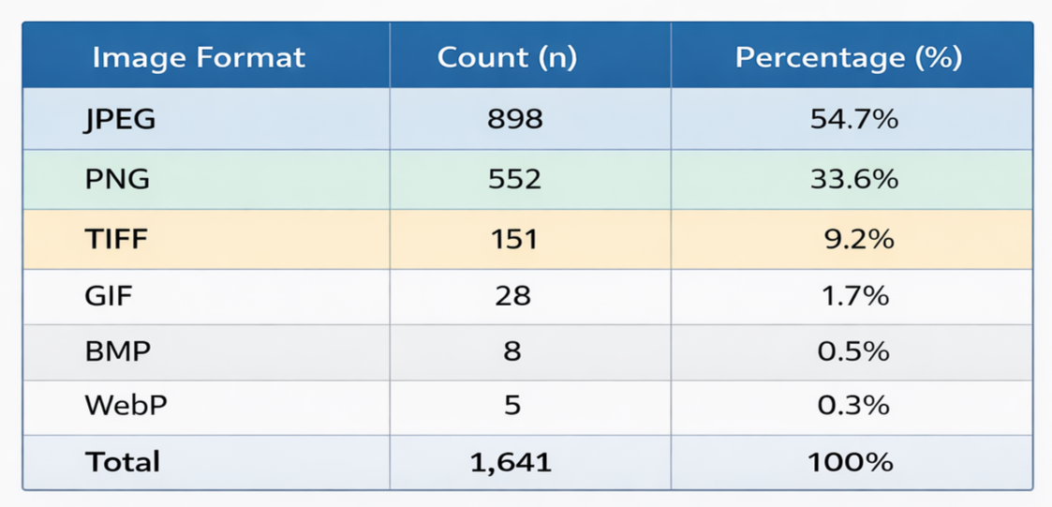
Note. Counts represent the number of files associated with each image format family identified within the sampled dataset of 1,641 files. Format families were determined based on PRONOM identifiers assigned during the DROID format identification process.
Research Question 3: Which formats exhibit characteristics associated with preservation risk according to documentation and software support recorded in the PRONOM registry?
After identifying the file formats and determining their frequency of occurrence throughout the sample, each unique format identifier was evaluated using information from the PRONOM technical registry. Documentation about format specifications, software support, and technical dependencies was reviewed to assess possible preservation concerns. These characteristics help indicate whether a format is likely to remain accessible over time. Formats with strong documentation and broad software support were considered less likely to face long-term access problems. In contrast, formats that rely on specialized technologies or limited documentation (indicative of an emerging format) were considered to present greater preservation risks.
Formats with openly documented specifications and widespread software support were classified as low preservation risk. These include widely used formats such as JPEG, PNG, TIFF, and GIF. These formats are supported by many software environments and have well-established technical documentation. Their widespread adoption across imaging platforms and repository systems helps ensure continued accessibility. As a result, files stored in these formats are less likely to encounter significant preservation challenges. Table 2 presents the preservation risk classification of the identified image format families based on PRONOM documentation.
Table 2 presents the preservation risk classifications assigned to each identified file format within the sampled dataset.
Table 2
Preservation Risk Classification of Identified Image Format Families
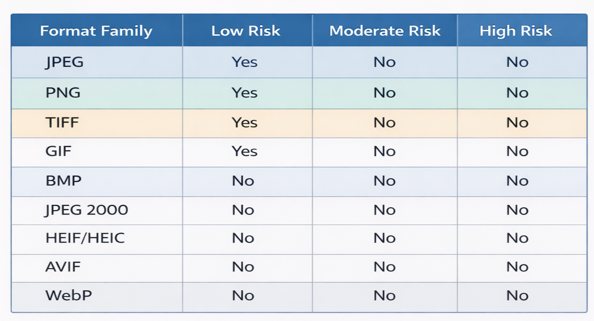
Note. Risk classifications are based on documentation availability, software support, and technological dependencies recorded in the PRONOM technical registry. Formats classified as low risk exhibit broad compatibility and open documentation, while moderate-risk formats show more limited support or reliance on specialized technologies. No formats in the dataset were classified as high preservation risk.
A smaller group of formats, including JPEG 2000 variants, HEIF/HEIC, and AVIF, was classified as moderate preservation risk. Although these files can still be accessed and currently remain usable, they depend on specialized codecs and generally have fewer users and limited adoption than traditional image formats. Compared with formats such as JPEG or PNG, they may require more specific software environments for proper downloading. These dependencies could create future access challenges if software support diminishes. For this reason, formats in this category may require closer monitoring.
No formats identified in the dataset were classified as high preservation risk. All formats had available technical documentation and at least some level of current software support. This finding suggests that the repository content analyzed in the study primarily uses formats that remain accessible today. However, continued monitoring of repository formats is still important because technologies and software environments change over time. Future analyses may identify higher-risk formats as new file types emerge or as existing technologies become obsolete.
Research Question 4: What proportion of the sampled files are stored in formats classified as sustainable for long-term digital preservation?
To answer the final research question, the study examined how many formats in the dataset could be considered sustainable for long-term preservation. Formats considered low preservation risk were considered sustainable because of strong open documentation, widespread use, and broad software support. Formats that possess these characteristics are more likely to remain accessible in the near term despite technological changes. Examining collections and evaluating content sustainability in this way makes identifying stable formats that are less likely to become obsolete in the near-term simpler. This assessment provides an overview of the files’ format stability status, informing future preservation planning and format management decisions.
There were 22 unique format identifiers found in the dataset, of which 16 formats (72.7%) were classified as low preservation risk and 6 formats (27.3%) were classified as moderate preservation risk. These describe the distribution of format types rather than the number of individual files stored in each format. No formats were classified as high preservation risk based on the criteria used in this study. These results indicate that most formats in the sampled repository content have characteristics associated with sustainable digital formats. Overall, the findings suggest that the repository datasets analyzed in the study primarily contain formats that remain suitable for long-term access.
Figure 2 illustrates the distribution of preservation risk classifications among the identified formats.
Figure 2
Preservation Risk Distribution of Identified Image Formats
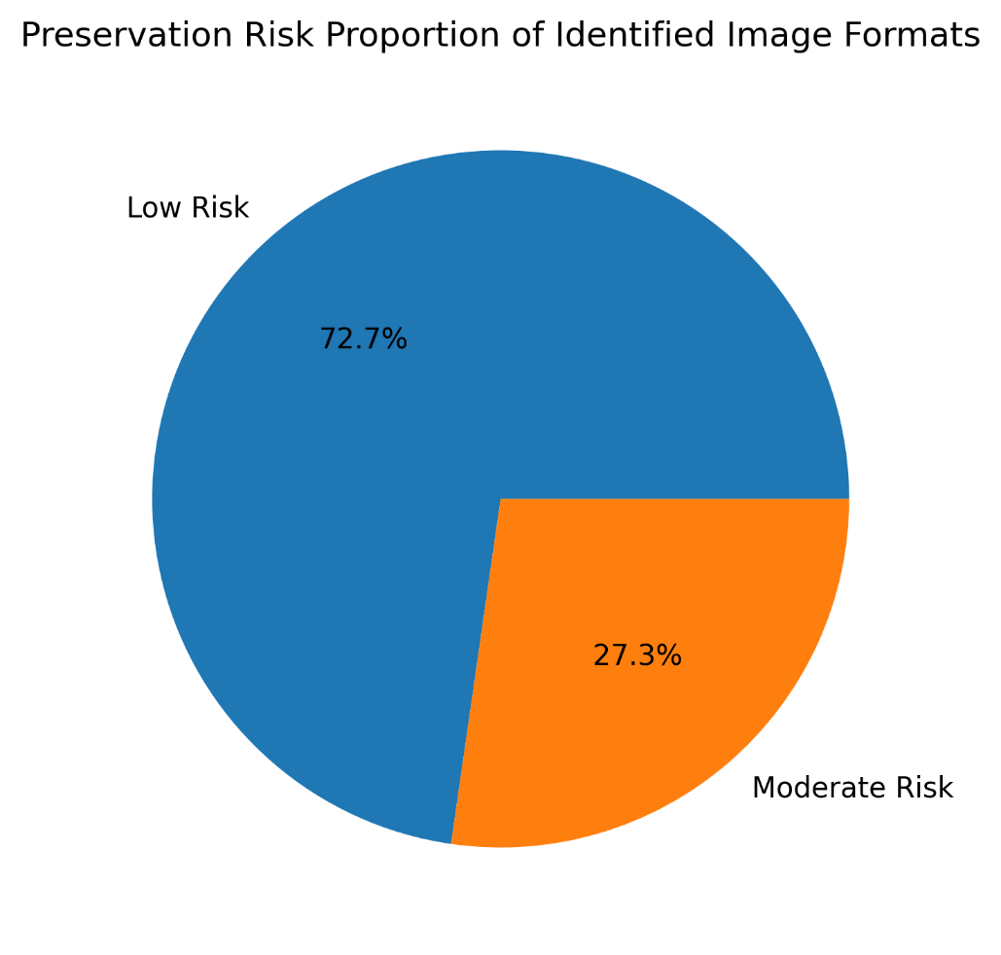
Note. Percentages represent the proportion of identified image file formats classified as low or moderate preservation risk based on documentation availability, software support, and technological dependencies recorded in the PRONOM technical registry.
The results of this study indicated that the sampled content consists primarily of data stored in established and widely supported image formats. A smaller number of files were encoded in emerging or specialized formats such as AVIF, HEIF/HEIC, and JPEG 2000. These findings provide an empirical overview of the image file formats present within the sampled repository content. The distribution of the file formats highlights the continued dominance of a small number of widely adopted formats within repository environments. Together, these results establish the basis for examining the preservation implications of repository format practices in the following chapter.
DISCUSSION
Opening Summary of Findings
In the analysis of the sample, DROID identified 22 unique image formats that made up the 1,641 image files. Most were stored in widely used formats such as JPEG, PNG, TIFF, and GIF, which all have open documentation and broad software support. Because of those factors, they were classified as low risk for obsolescence in the near-term. A smaller group of formats, including JPEG 2000 variants, HEIF/HEIC, and AVIF, was classified as moderate risk because they are less widely used or require specialized software for access. No formats were classified as high risk, suggesting that most image files in the Harvard Dataverse sample are stored in formats with stable documentation and strong software support.
Answering the Research Questions
The findings of this study addressed the research questions by identifying the image file formats present in a sample of files from the Harvard Dataverse repository and evaluating their preservation risk. The analysis focused on understanding the technical composition of repository content and its implications for long-term digital preservation. By examining format distribution and preservation characteristics, the study provided empirical insight into the sustainability of image formats in a repository environment. These results provide a foundation for interpreting the preservation implications of the identified formats. They also contribute to broader discussions about format sustainability and repository management in digital preservation research.
The first research question examined which image formats were present in the sampled repository content. Automated format identification using DROID identified 22 distinct file format identifiers (PUIDs). These identifiers represent several major format families, including JPEG, PNG, TIFF, GIF, JPEG 2000, HEIF/HEIC, and AVIF. The results show that the repository sample contains a range of image formats commonly used in digital collections. This diversity reflects the variety of image creation practices and technical environments represented in repository datasets.
The second research question examined which formats showed characteristics associated with preservation risk based on information from the PRONOM registry. Analysis of format documentation and software support showed that most formats have strong documentation and broad software compatibility. These formats were therefore classified as low preservation risk. A smaller group of formats, particularly JPEG 2000 variants, HEIF/HEIC, and AVIF, were classified as moderate risk because they are less widely adopted or depend on specialized software. These results suggest that while widely supported formats dominate the dataset, some newer formats may require additional monitoring.
The third research question examined the proportion of files associated with preservation risk categories. The results showed that most files in the dataset are encoded in formats considered stable in current computing environments. Only a small number of formats showed characteristics associated with moderate preservation risk. No formats in the sample were classified as high risk. These findings indicate that the repository content analyzed in the study largely relies on formats that remain well supported by current software.
Together, these findings provide an empirical overview of format distribution and preservation risk in the analyzed repository content. The results show that widely supported image formats represent the majority of files within the dataset. At the same time, the presence of newer formats reflects the ongoing development of digital imaging technologies. These findings improve understanding of the preservation characteristics of image files stored in institutional repositories. They also highlight the importance of monitoring repository formats as technologies and software environments continue to change.
Prevalence of Established Image Formats
The files selected from the Harvard Dataverse show that contributors often rely on well-established and familiar image formats, with JPEG, PNG, and TIFF making up the vast majority of the dataset. Their continued accessibility is due to them being widely supported across many platforms and digital image tools and programs. This corresponds with research that shows that formats with wide adoption and open documentation are more likely to remain usable and accessible over time (Lawrence et al., 2000; Rosenthal, 2018). The results of this study support those findings. As a result, the immediate risk of format-related access problems within the dataset appears relatively low, highlighting the importance of format selection in digital preservation planning.
The presence of multiple PUIDs associated with JPEG and TIFF formats also illustrates the complexity of format identification. Files that appear identical based on appearance and even file extension may actually correspond to different format versions or possess different internal structures. By examining the internal file signatures rather than simply relying on file extensions, DROID and the PRONOM registry can detect those important differences. Being able to identify these differences is important because different format variants may have other technical requirements or preservation implications. Accurate format identification therefore plays an important role in supporting effective digital preservation and repository management.
Emerging and Moderately Supported Formats
Although most formats in the dataset were classified as low risk, several moderately supported formats highlight the changing nature of digital imaging technologies. Formats such as JPEG 2000, HEIF/HEIC, and AVIF were developed to improve image quality and compression efficiency when compared with older formats. However, these formats often depend on specialized software or codec support that may not yet be widely available. This dependence may create preservation challenges if software support stalls or declines in the future. Therefore, formats in this category may require continued monitoring.
Despite offering image improvements over traditional JPEG compression, JPEG 2000 serves as a better example of this issue. It has not been widely adopted outside specialized areas like geospatial imaging, medical imaging, and digital preservation. Because of that and its limited applications, software support for some JPEG 2000 variants is much less common than that for standard JPEG. Newer formats such as HEIF and AVIF also rely on newer compression technologies that are still evolving. These traits explain why these formats were classified as moderate preservation risk in the study.
The presence of these formats in the dataset illustrates the importance of monitoring emerging file formats and technologies. As new tools for creating and storing images are created and adopted, repositories may contain files in formats whose long-term sustainability has not yet been established. Tracking format adoption can help institutions identify possible preservation risks early. This type of monitoring supports planning for long-term digital preservation. It also helps repository managers make informed decisions about format management and preservation strategies.
Implications for Repository Preservation Practices
The findings emphasize the importance of continuous format monitoring within digital repository environments. Digital preservation frameworks such as the Open Archival Information System (OAIS) stress the need for ongoing preservation planning and technological surveillance to maintain access to digital materials over time (Consultative Committee for Space Data Systems, 2012; Lavoie, 2014). Automated format identification tools such as DROID provide a practical mechanism for implementing this monitoring process. By routinely analyzing repository content, institutions can identify potential format-related preservation risks before they affect long-term accessibility. Integrating such monitoring practices into repository management workflows supports more proactive digital preservation strategies.
Analyzing file formats at scale allows repositories to better understand the technical composition of their collections. This knowledge enables repository managers to identify formats that may require additional preservation attention, such as format migration planning or the maintenance of specialized rendering software. Large-scale format analysis also helps institutions track changes in format usage over time. These insights support more informed preservation decision-making within repository environments. Such analytical approaches therefore contribute to more proactive and sustainable digital preservation strategies.
The methodology used in this study demonstrates how automated tools and format registries can be integrated into repository workflows. The combination of DROID format identification and PRONOM documentation provides a scalable approach for evaluating the sustainability of repository content as collections continue to grow in size and complexity. Integrating such tools into routine repository management practices can support systematic monitoring of digital collections. These workflows therefore contribute to more proactive digital preservation strategies. Applying automated format analysis in this way enables repositories to respond more effectively to evolving technological environments.
Relation to Previous Research
The findings of this study reflect several themes found in digital preservation research. Early studies emphasized the fragility of digital materials and the risks created by technological change (Hedstrom, 1997; Conway, 2010). More recent research highlights the importance of institutional repositories as key systems for managing digital scholarly materials (Phillips, 2015; Narlock et al., 2024). Together, these perspectives show that both technological tools and institutional practices are important for digital preservation. The results of this study illustrate how these ideas appear in the practical management of repository content.
Much of the existing literature focuses on preservation frameworks or institutional readiness rather than the technical details of repository files. By applying automated format identification to repository files, this study provides empirical evidence about the image formats used within an institutional repository. This approach helps reveal the technical composition of repository collections. Such analysis helps connect preservation theory with the practical management of digital materials. Examining formats at the file level therefore provides useful insight for repository preservation planning.
The results also support earlier observations that digital collections often rely on a small number of widely used formats. At the same time, repositories also contain smaller numbers of newer or specialized formats. This pattern reflects the evolving nature of digital technologies and the varied practices of researchers depositing materials. Understanding these patterns helps institutions develop more effective preservation strategies. Monitoring format diversity therefore remains an important part of digital stewardship.

Limitations and Future Research
Some limitations must be considered when interpreting this study’s findings. The study analyzed image files only, drawn from a sample of datasets within the Harvard Dataverse repository. Other types of digital materials, such as audiovisual files, research datasets, or software, were not analyzed. Because of this, the findings reflect the characteristics of image files exclusively, rather than the full range of materials stored in the repository. Future studies that include additional file types could provide a broader understanding of format diversity in repositories.
The study relied on the automated format identification tool, DROID, and information from the PRONOM registry to evaluate preservation risk. While these tools are widely used in digital preservation practice, they cannot be used to predict how technologies will change in the future. Therefore, risk classifications should be understood as indicators of possible concerns rather than definitive predictions of future accessibility. Changes in software, technological standards, or user patterns may affect the long-term sustainability of formats. Digital preservation research recognizes that maintaining access over time requires continuous monitoring and management of digital formats.
Future research could expand this work by analyzing larger samples of repository files or by examining multiple repositories. Comparing repositories from different disciplines or institutions could reveal broader patterns of format use. Long-term studies that track format distributions over time could also show how technological changes affect repository content. This type of research would help researchers understand how digital formats evolve within preservation environments. This work would support more evidence-based preservation planning for digital repositories.
CONCLUSION
Institutional Repository Context
This study contributes to current literature and studies about the role and responsibilities of institutional repositories in digital preservation. Originally created to support open access to scholarly work, repositories now play a broader role in managing research data and supporting long-term preservation. As they continue to grow in both size and significance, it becomes more important to understand the technical characteristics of their digital holdings. Identifying the file formats within these collections helps reveal how sustainable those materials are over time. This type of analysis gives institutions a clearer understanding of the preservation challenges associated with their digital content.
Research on institutional repositories shows that many systems still focus more on providing access than on long-term preservation. As a result, repositories may store large numbers of digital objects without closely evaluating the sustainability of their file formats. This gap points to a key limitation in current repository practices, since format sustainability directly affects long-term access. Previous studies have emphasized the need for stronger policies, tools, and workflows to support digital preservation efforts. Incorporating format analysis into repository workflows can help institutions identify potential risks early and make more informed preservation decisions.
Within the sampled dataset, most files were stored in formats that are widely supported by current software. However, the presence of newer or more specialized formats shows why ongoing monitoring is important. Even if formats are accessible today, changes in software, codecs, or platforms could affect future access. Regularly reviewing format characteristics allows repositories to identify potential issues before they become serious problems. Taking this proactive approach can help institutions build more resilient and sustainable digital preservation strategies.
Broader Implications
The results support a key idea in digital preservation: long-term access depends not only on storing files but also on understanding the formats used to create them. Format identification tools and technical registries help repositories track the sustainability of their digital collections. By documenting format details and software dependencies, these tools help institutions identify possible preservation risks. Incorporating these tools into repository workflows allows institutions to make better preservation decisions. These practices strengthen an institution’s ability to manage digital collections as technologies continue to change.
As repositories grow and new media formats appear, understanding the technical makeup of digital collections becomes increasingly important. Identifying the formats stored in repositories and evaluating their potential risks helps institutions plan preservation activities more effectively. Regular analysis of repository content also allows institutions to monitor technological changes over time. This monitoring helps repositories respond early to emerging preservation challenges. In this way, format analysis supports the long-term sustainability of digital scholarly resources.
Conclusion
This study analyzed image file formats randomly selected from the Harvard Dataverse repository to determine their potential preservations risks. DROID was used to identify each file’s format, combined with documentation from the PRONOM registry to evaluate their risk of obsolescence. Using available documentation, software support, and technical dependencies to assess each file’s risk level, the analysis focused on understanding the technical makeup of the content and its implications on digital preservation. Through this method of analysis, the study provides empirical data on the sustainability of image formats stored within a large institutional repository.
The study revealed that most of the sampled files were stored in a relatively small number of widely supported image formats, most commonly JPEG, PNG, and TIFF. Because these formats have open specifications and are compatible with many current software environments, they present very low risk of obsolescence in the short-term. Because they are widely used, they are examples of ongoing and continued access in the institutional repository. The prevalence of these file types implies that repository contributors often rely on familiar and well-established file formats. This pattern suggests that format choice is possibly influenced by both convenience and awareness of long-term accessibility.
A smaller number of files were stored in formats classified as moderate risk, including JPEG 2000 and newer formats such as HEIF and AVIF. Although these formats remain usable, they often depend on specialized codecs or have more limited software support than traditional formats. This reliance on specific technologies could create preservation challenges if software support declines. Monitoring the adoption of these formats is therefore important for identifying potential risks. Continued attention to emerging formats can help repositories anticipate future preservation needs.
Overall, the findings indicate that the sampled repository content largely relies on widely supported image formats. However, the presence of format variants and newer formats highlights the importance of ongoing monitoring. Even formats that are accessible today may face challenges if software ecosystems or technological standards change. Regular format analysis can help repositories respond to these changes more effectively. Monitoring format trends within collections remains an important part of responsible digital stewardship.
The study also demonstrates the value of combining automated format identification with technical registries to evaluate preservation risks. Tools such as DROID and PRONOM allow repository managers and digital archivists to identify formats and assess their long-term sustainability. Integrating these tools into repository workflows can support systematic monitoring of digital collections. These practices help institutions make more informed decisions about preservation planning. Applying such tools consistently can strengthen the long-term stewardship of digital repository content.
Based on these findings, institutional repositories may benefit from implementing routine format monitoring. Regular format audits using automated tools such as DROID can help identify emerging risks and support preservation planning. Incorporating format analysis into repository management practices may encourage more proactive digital preservation strategies. Monitoring format use also helps institutions track changes as repository collections grow. Establishing systematic format analysis workflows can therefore strengthen long-term preservation planning.
Future research could expand this work by analyzing additional types of digital materials beyond image files. This could include audiovisual content, research datasets, and software commonly stored in institutional repositories. Studies examining multiple repositories could also provide broader insight into format diversity across preservation environments. Long-term studies tracking format distributions over time may further clarify how technological change affects format sustainability. Additional research on emerging image formats may also help anticipate future preservation challenges.
Although the sampled dataset did not reveal widespread use of obsolete formats, the study highlights the importance of ongoing format monitoring. As repositories expand and new formats emerge, understanding the technical composition of collections becomes increasingly important. Automated format analysis can provide repository managers with information needed to anticipate technological change. This information helps institutions plan preservation actions and maintain long-term access to digital materials. As digital collections continue to grow, regular format analysis will remain an essential practice for sustaining access to born-digital archival records.

REFERENCES
Abrams, S., & Luther, A. (2010). Validating digital objects: The use of JHOVE in large-scale repository workflows. Proceedings of the International Conference on Digital Preservation (iPRES).
Ahmad, R., Rahman, A., & Karim, N. A. (2022). Assessing the preparedness of university libraries for digital preservation programs. Journal of Academic Librarianship, 48(6).
Anyaoku, E. N. (2019). Digital preservation practices in university libraries: An exploratory study. Digital Library Perspectives, 35(3).
Consultative Committee for Space Data Systems. (2012). Reference model for an open archival information system (OAIS) (ISO 14721:2012). https://public.ccsds.org/pubs/650x0m2.pdf
Conway, P. (2010). Preservation in the age of Google: Digitization, digital preservation, and dilemmas. The Library Quarterly, 80(1), 61–79. https://doi.org/10.1086/648464
Creswell, J. W., & Creswell, J. D. (2018). Research design: Qualitative, quantitative, and mixed methods approaches (5th ed.). SAGE.
Digital Preservation Coalition. (2023). Digital preservation handbook (2nd ed.). https://www.dpconline.org/handbook
Dollar, C. M., & Ashley, L. (2014). Digital preservation capability maturity model (DPCMM): Background and performance metrics.
Eve, M. P. (2024). Digital scholarly journals are poorly preserved: A study of preservation coverage. Journal of Librarianship and Scholarly Communication, 12.
Harvard Dataverse Project Documentation. (n.d.). Harvard University. https://guide.dataverse.org/
Hedstrom, M. (1997). Digital preservation: A time bomb for digital libraries. Computers and the Humanities, 31(3), 189–202. https://doi.org/10.1023/A:1000682310461
Jalaludin, U. N., Rahman, N. A., & Ismail, R. (2025). Digital preservation in digital libraries: A systematic literature review. International Journal of Research and Innovation in Social Science.
Johnston, L. (2020). Challenges in preservation and archiving digital materials. Information Services & Use, 40(3–4).
Kaczmarek, J. (2017). Developing digital preservation programs: The Digital Preservation Capability Maturity Model (DPCMM) and its application. Journal of Archival Organization, 14(1–2), 43–57. https://doi.org/10.1080/15332748.2017.1331671
Knight, G. (2015). DROID and PRONOM: Tools and resources for digital preservation. The National Archives (UK). https://www.nationalarchives.gov.uk
Krishnamurthy, C. (2024). Trends in digital file formats for long-term preservation. Journal of Library and Information Science.
Lavoie, B. F. (2014). The open archival information system (OAIS) reference model: Introductory guide (2nd ed.). Digital Preservation Coalition. https://www.dpconline.org/docs/technology-watch-reports/1359-twr14-02/file
Lawrence, G. W., Kehoe, W. R., Rieger, O. Y., Walters, T. O., & Kenney, A. R. (2000). Risk management of digital information: A file format investigation. Council on Library and Information Resources. https://www.clir.org/pubs/reports/pub93/
Matthews, B., McIlwrath, B., Giaretta, D., & Conway, E. (2008). The significant properties of software: A study. Joint Information Systems Committee (JISC). https://www.jisc.ac.uk/reports/the-significant-properties-of-software
Narlock, M. R., Calvert, S., Taylor, S., Marquez Priesman, R., Parkman, A. (2024). Knowledge infrastructures are growing up: Institutional repositories and research data sharing. Data Science Journal, 23.
Ndegwa, H. (2022). The status of digital preservation policies and plans in institutional repositories. Insights: The UKSG Journal, 35.
Park, J., & Tosaka, Y. (2010). Metadata quality in digital repositories: A survey of current practices. Library Resources & Technical Services, 54(4), 265–278. https://doi.org/10.5860/lrts.54n4.265
Phillips, M. (2015). The role of institutional repositories in digital preservation. Library Hi Tech, 33(2), 222–234. https://doi.org/10.1108/LHT-11-2014-0109
REMEDi4ALL. (n.d.). Research infrastructure (RI). Retrieved February 21, 2026.
Rieh, S. Y., Yakel, E., Markey, K., St. Jean, B., & Kim, J. (2007). Perceptions and experiences of institutional repositories: Findings from the 2005 Census of Institutional Repositories. D-Lib Magazine, 13(11/12). https://doi.org/10.1045/november2007-rieh
Rieger, O. Y. (2021). The effectiveness and durability of digital preservation and curation systems. Ithaka S+R.
Rosenthal, D. S. H. (2018). Format obsolescence: Assessing the threat and the evidence. International Journal of Digital Curation, 13(1), 213–231. https://doi.org/10.2218/ijdc.v13i1.616
Shekgola, M. M. (2025). Ingesting digital archives into long-term storage systems using open-source tools. Collection and Curation.
The National Archives (UK). (n.d.). PRONOM technical registry. https://www.nationalarchives.gov.uk/pronom/
Trognitz, M. (2024). Preserving digital data without an archive. International Archives Journal.
Appendix A
Python Sampling Script and Repository Access
The dataset used in this study was generated through an automated Python workflow designed to retrieve and randomly sample image files from the Harvard Dataverse repository using the Dataverse application programming interface (API). The script queried the repository for files identified as image content, filtered the results to identify eligible files, and randomly selected files until the target sample size of 1,641 files was reached. Because the script controlled the number of files retrieved using a configurable parameter, expanding the sample size from a small test dataset to the full sample required minimal modification. Once the workflow was implemented, retrieving and processing 1,641 files required essentially the same programming effort as retrieving a much smaller number of files. A simplified excerpt of the Python script used for file sampling is provided below.
import requests
import random
API_URL = "https://dataverse.harvard.edu/api/search"
params = {
"q": "fileType:image",
"type": "file",
"per_page": 100
}
response = requests.get(API_URL, params=params)
data = response.json()
files = data["data"]["items"]
sample_files = random.sample(files, 1641)
for file in sample_files:
download_url = file["url"]
# Code used to download file locally
The excerpt above demonstrates the logic used to query the Dataverse API and randomly select files from the pool of eligible image files. The full script includes additional code for pagination, metadata handling, and automated file downloading.

Appendix B
Example Structure of DROID Output
The DROID format identification tool generated a report describing the technical format characteristics of each file scanned in the dataset. The report includes several metadata fields describing the file and its identified format. Table B1 presents an example of the structure of the output generated by DROID.
Table B1
Example Structure of DROID Format Identification Output
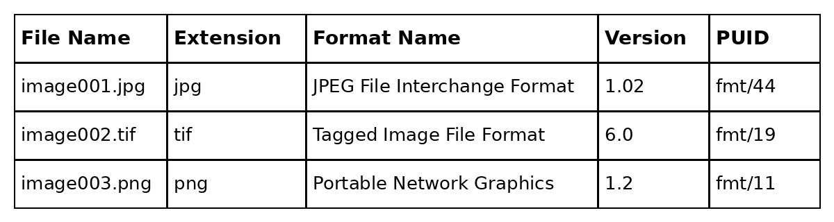Note. Format identification fields were generated automatically by DROID using PRONOM format signatures.

Appendix C
Data Structure for Format Analysis Dataset
This appendix presents the column structure used in the spreadsheet compiled from the DROID output for analysis in Microsoft Excel. The dataset included metadata fields necessary for identifying file formats, assigning Persistent Unique Identifiers (PUIDs), and evaluating preservation risk. Organizing the data in this structure supported the calculation of format frequencies and the assignment of preservation classifications.
Table C1
Data Structure for Format Analysis Dataset
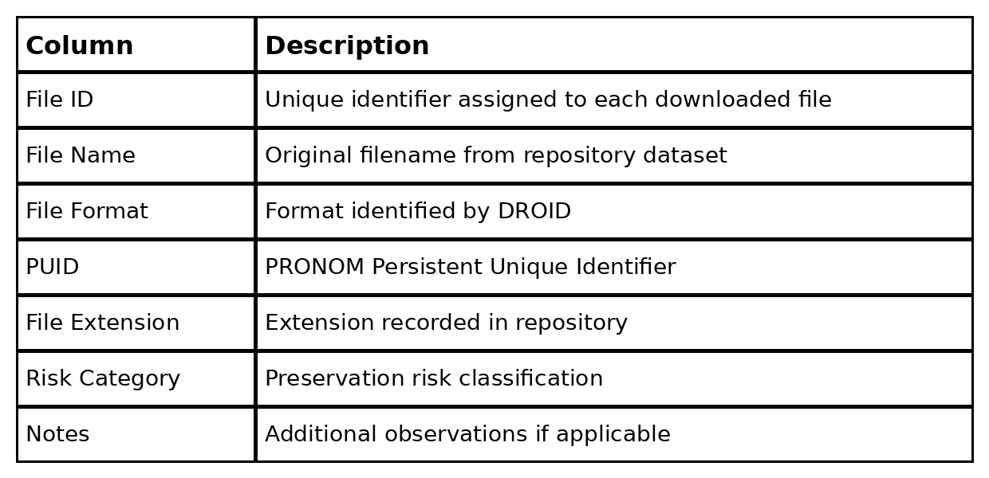
Note. The column structure shown in this table represents the spreadsheet format used to compile and analyze the output generated by the DROID format identification tool. Metadata fields were derived from the automated format identification process and supplemented with preservation risk classifications based on documentation provided in the PRONOM registry. The structure allowed the dataset to be organized for calculating format frequency distributions and evaluating preservation risk characteristics.

Appendix D
Sample Rows from the Format Analysis Dataset
This appendix provides example rows from the compiled spreadsheet used for analysis. These sample entries illustrate how the DROID output was organized into a structured dataset for identifying file formats and evaluating preservation risk. Including example rows helps clarify the relationship between the original DROID output and the spreadsheet used for analysis.
Table D1
Sample Spreadsheet Rows
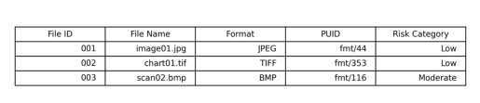
Note. The rows shown illustrate the structure of the compiled dataset used for analysis. Values were derived from the DROID format identification report and organized in a spreadsheet to support analysis of format prevalence and preservation risk. The rows are examples only and do not represent the complete dataset of 1,641 files analyzed in the study.

Appendix E
Complete List of Identified Image Formats
The automated format identification process identified 22 distinct Persistent Unique Identifiers (PUIDs) corresponding to the image formats present within the sampled dataset. These identifiers represent the unique format signatures detected during the DROID scanning process.
Table E1
Identified Image Formats and Preservation Risk Classification
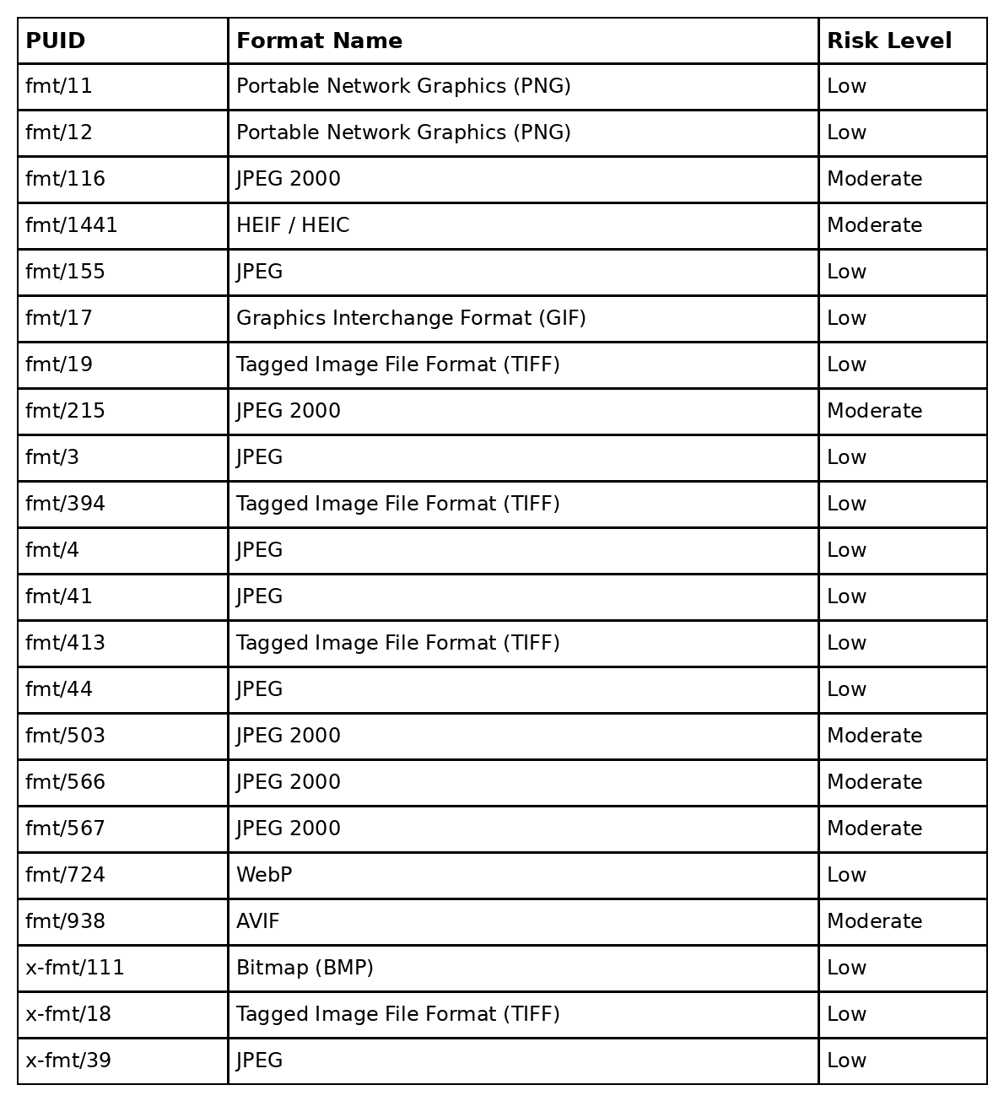
Note. The formats listed represent the Persistent Unique Identifiers (PUIDs) detected by the DROID format identification tool during analysis of the sampled dataset. PUIDs correspond to format signatures documented in the PRONOM technical registry and provide standardized identifiers for digital file formats. Preservation risk classifications were assigned using format documentation, software support, and adoption information provided by PRONOM, indicating the relative sustainability of each format for long-term digital preservation.

Appendix F
Preservation Risk Classification Criteria
Format risk levels were determined using technical documentation provided by the PRONOM registry. Risk classifications were assigned according to the following criteria.
Low Risk
Formats classified as low risk exhibit the following characteristics:
• Openly documented technical specifications
• Broad compatibility across operating systems and software tools
• Evidence of widespread adoption within digital imaging workflows
• Multiple independent software implementations capable of rendering the format
• Examples include JPEG, PNG, TIFF, GIF, and BMP
Moderate Risk
Formats classified as moderate risk exhibit one or more of the following characteristics:
• Limited software compatibility relative to widely adopted formats
• Dependence on specialized codecs or proprietary technologies
• Emerging adoption patterns with evolving software support
• Partial documentation or inconsistent implementation across platform
• Examples include JPEG 2000 variants, HEIF/HEIC, and AVIF.
High Risk
Formats classified as high risk would exhibit characteristics such as:
• Lack of publicly available technical documentation
• Dependence on obsolete or discontinued software environments
• Inconsistent or unreliable format identification
• Limited evidence of continued software support
• No formats identified in the dataset met the criteria for high-risk classification.
Figure F1
Preservation Risk Proportion of Identified Image Formats
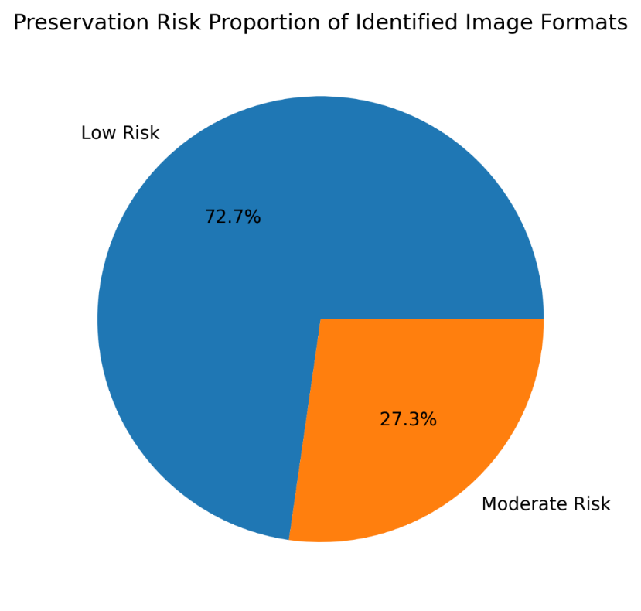
Note. The diagram illustrates the computational workflow used to collect, identify, and analyze file formats from the Harvard Dataverse repository. The process includes automated file sampling using a Python script, format identification with DROID, extraction of format identifiers, and evaluation of preservation risk using documentation from the PRONOM registry.

Appendix G
Research Workflow Diagram
Figure G1 illustrates the computational workflow used in this study to collect, identify, and analyze file formats from the Harvard Dataverse repository.
Figure G1
Research Workflow for Format Identification and Risk Assessment
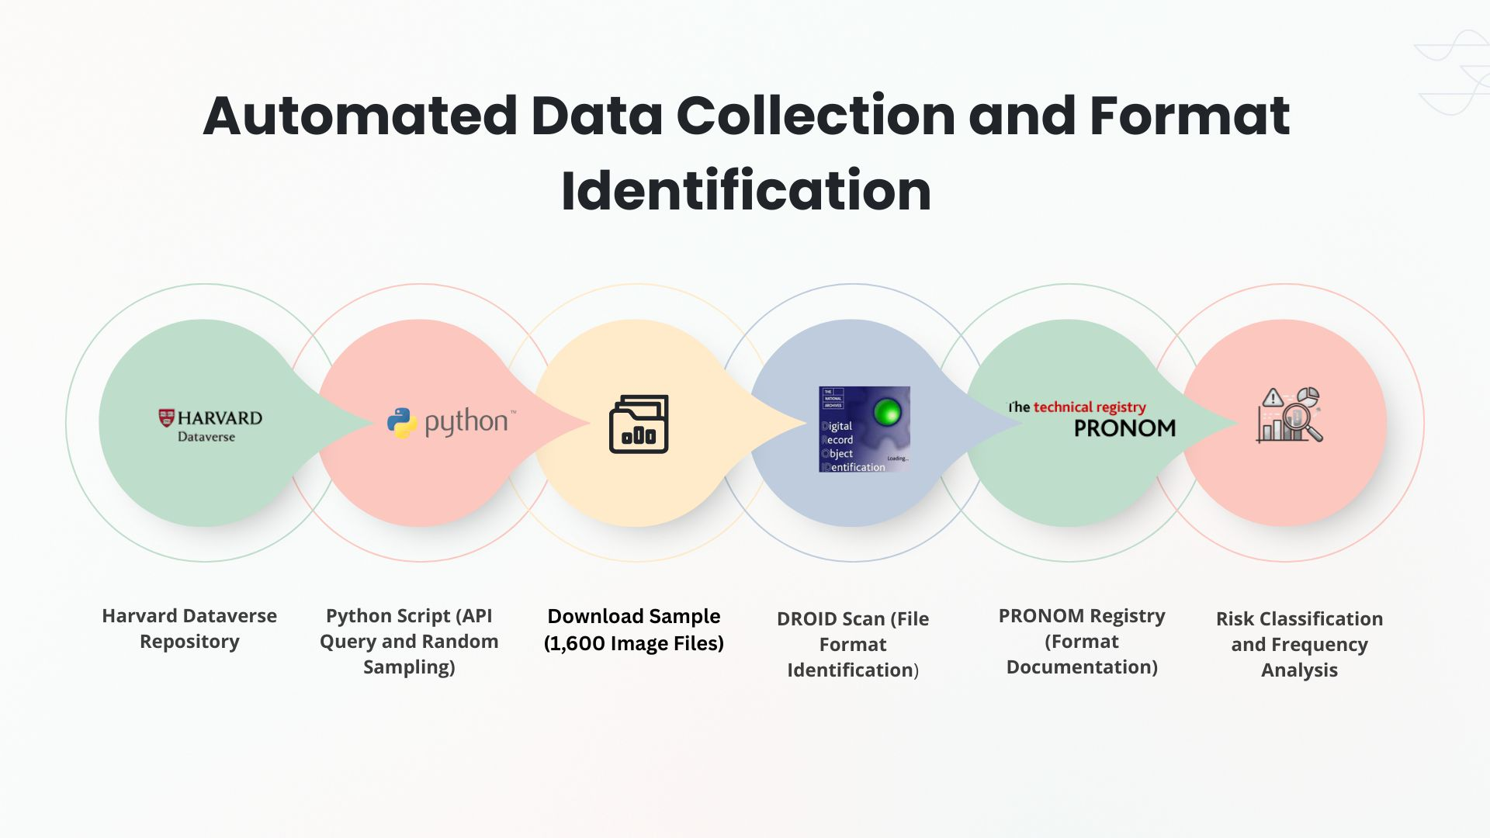
Note. The workflow diagram summarizes the automated data collection and format identification procedures used in this study.

